- Investigation and Plan

The topic I chose to investigate is housing in Ireland, which I believe its one of the most social concerned problems nowadays in Irish society. Much like the general election debates on RTE a few months ago, where different political parties discussed how to address the ongoing housing issues these were the highlights and captured the most public attention. According to Social Justice Ireland, “the Parliamentary Budget Office (PBO) report on Housing Affordability for Private Household Buyers in Ireland states that between 2011-2022, the population grew by 560,887, while the housing stock increased by only 117,276 units. ” (https://www.socialjustice.ie/article/addressing-irelands-housing-crisis-urgent-policy-reforms-needed). Interactive information systems have become an essential tool in delivering user-friendly, data-rich solutions across various fields, I believe the interactive information system I created “Housing Data Hub” will effectively help individuals find housing solutions tailored to their needs thus become beneficial to society by including concise SVG graph that highlights the disparities in housing costs across different regions of Ireland over the years. After I understood the reality of the problem, I started to find available data sets and any existing interactive information systems that could inspire my project. For example, by using the advance search function on Google, I found a website made by the Irish government.( https://www.housingagency.ie/ ) Extensive data can be downloaded and ready-made graphs are available on this website. It became the starting point of creating my interactive system. I downloaded the “ House price overburden” data, which measures the percentage of the population living in households where the total cost of housing exceeds 40% of their disposable income. The data is in CSV form so I can further process and visualize it with Python.

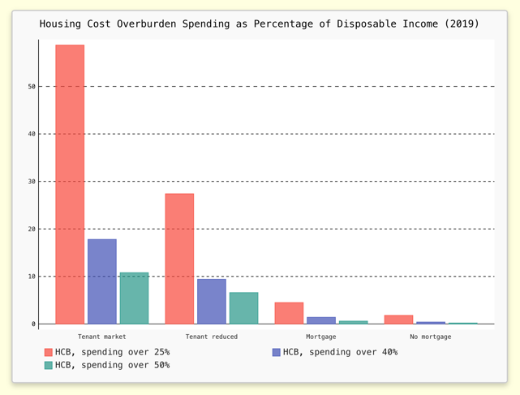
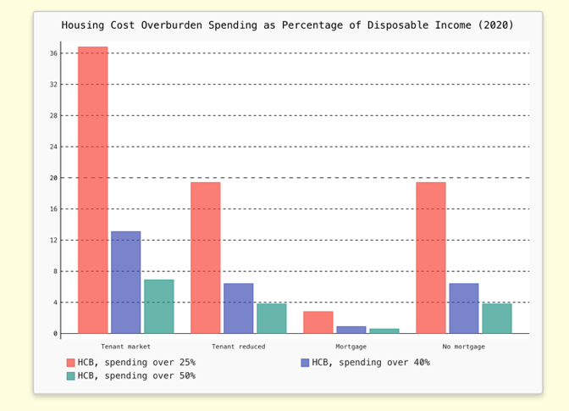

I found many interesting insights in these data during my further research into the topic. I noticed the HCO rate for households without mortgages in the year 2020 is significantly higher than in other years compare to household with mortgages. Logically, households without loans should be spending a smaller percentage of their disposable income on housing compared to those with loan obligations. Upon further research, I found that the COVID-19 pandemic was the key driver behind this phenomenon.

(https://tradingeconomics.com/ireland/housing-cost-overburden-rate-owner-no-outsting-mortgage-or-housing-loan-eurostat-data.html)

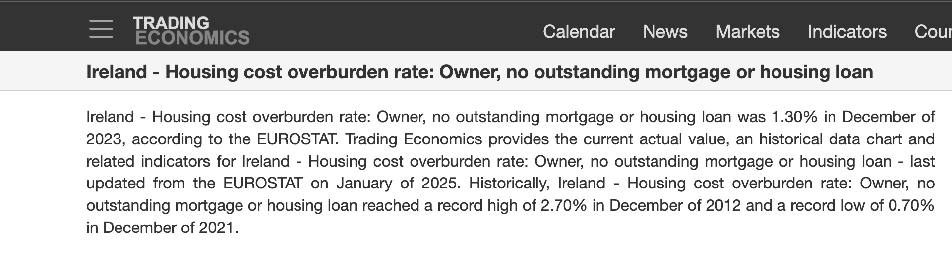


http://files.nesc.ie/nesc_background_papers/c19-housing.pdf

- People spent more time in door due to lockdown during the pandemic, this increased the utility cost, many households without loans are either those who have completed their mortgage payment or elderly individuals, their house are typically older with lower building energy rating (BER).

- Homeowners without mortgages often include a higher percentage of retirees or low-income households who rely on state benefits. During the pandemic, the government priorities budget for health care than other sector which will reduce the social welfare for these household.

- COVID-19 disrupted traditional data collection methods. Survey responses might have been less representative led to reporting distortions or inconsistencies.

2. Plan and Design

For instance, I arranged Housing Cost Overburden (HCO) according to four primary household tenures (Owner with a mortgage or loan, owner with no mortgage or loan, tenant renting at market price, and tenant renting at reduced price or free) base of three HCO rates - 25%, 40% and 50%.

